1. **Agenda**:
   1. How to configure roles in Spring Security.
2. 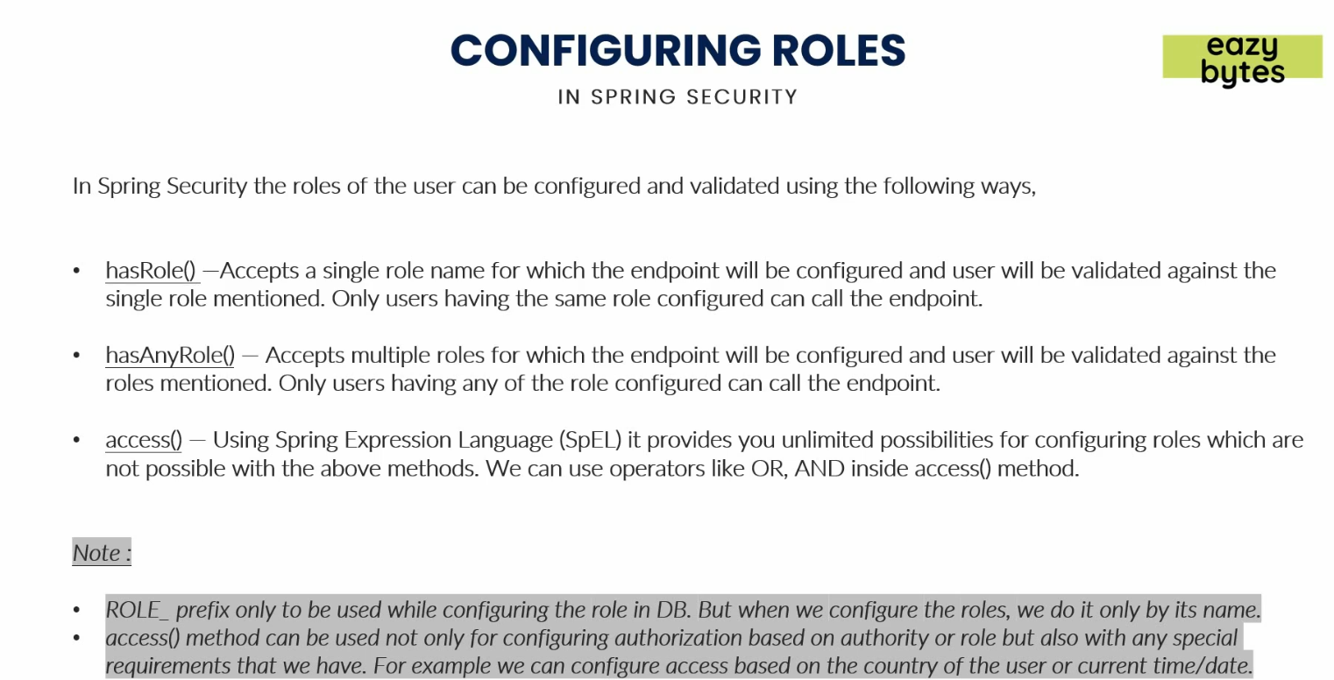
   1. Using these 3 methods we can configure based on roles.
   2. access(): If you have advanced configurations based on “and”, “or” etc.
3. 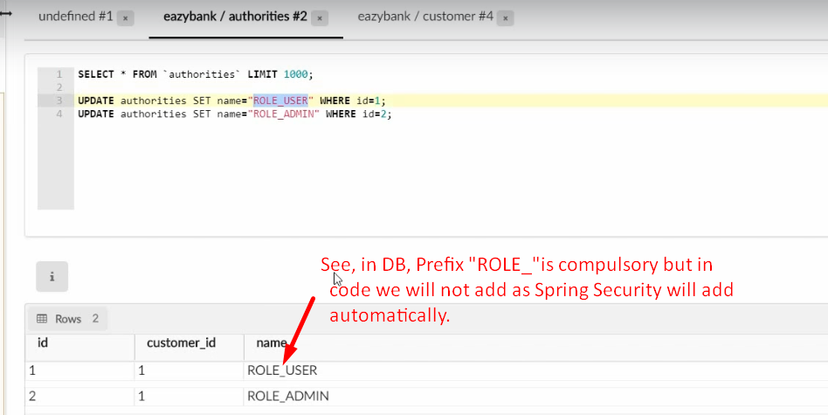  
   **NOTE**: in the above case, the same customer has two roles.
4. 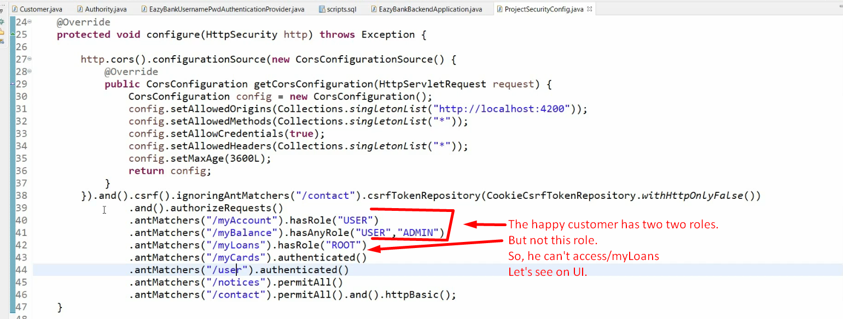
5. So far we’re using ant matcher, let’s see how to use other ways of matching the URLs in next lecture. 
6. 